Frequently Asked Questions

Q. Is the RPC able to assist with eRPT issues?
A. While the RPC relies heavily on eRPT we did not create, nor do we maintain the application. As indicated in the eRPT Plan User Manual, please contact the MAPD Help Desk at 1-800-927-8069 or mapdhelp@cms.hhs.gov if you are experiencing issues within the application.
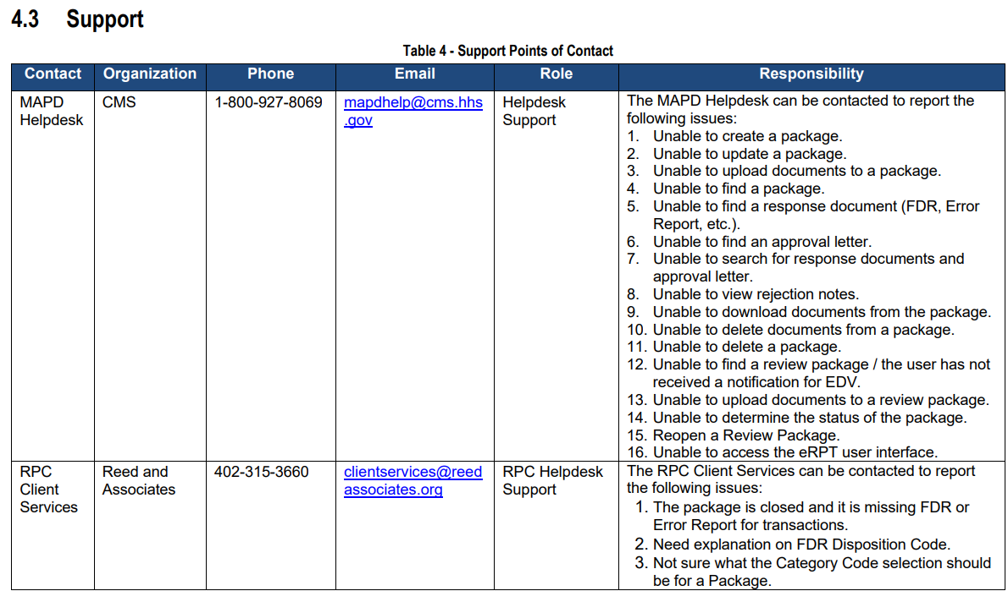

Q. Can more than one transaction be submitted on the RPC Submission Spreadsheet?
A. At this time, there is no limit to the number of transactions that can be submitted at one time. You can submit multiple transaction types as well. Please make sure to fill out all required fields to ensure that you do not receive an error.

Q. Is it possible to expedite a transaction so it can be processed as soon as possible?
A. The RPC cannot expedite the processing of a transaction without permission from CMS Central Office. Please work with your Account Manager to make this request to CMS Central Office. If permission is granted, the RPC will process the request accordingly.

Q. I submitted a Submission Package approximately a month ago and have not received a response. Why?
A. If the status of the Submission Package is not ‘In Process,’ the RPC has not yet received the transactions for review. Please refer below to see a full explanation of each status type.
1. Draft – If the Submission Package is in ‘Draft’ status, this indicates that it has not yet been submitted by your organization.
2. Pending Approval – If the Submission Package is in ‘Pending Approval’ status, this indicates that your Account Manager has not yet provided approval. If it is still in this status for an extended period, please reach out to your Account Manager.
3. Open – If the Submission Package is in ‘Open’ status, this indicates that the package has been submitted. If the package is stuck in ‘Open’ Status for an extended period of time, please reach out to the MAPD Help Desk to report the issue.
4. Downloading – If the Submission Package is in ‘Downloading’ status, this indicates that the RPC is receiving your Submission Package.
5. In Process – If the Submission Package is ‘In Process,’ the RPC has received it and the transactions will be processed in the order in which they are received.
6. Closed – If the Submission Package is in ‘Closed’ status, the RPC has reviewed the transactions submitted and all Final Disposition Reports (FDRs) and Error Reports should be present.

Q. I received disposition code 540 on the FDR indicating that the incorrect transaction type was used. What transaction type should I have used to submit this request?
A. If MARx indicates that the beneficiary has been enrolled in the requested contract/PBP for the requested effective date at any point, the transaction will need to be submitted as a reinstatement.

Q. I received an FDR indicating that the submitted request was coded favorably. I later received a follow-on FDR indicating that the update was removed. Why?
A. To ensure that Reed & Associates is accurately and consistently adhering to CMS Guidance, transactions are reviewed through an internal Quality Assurance process. If it is found that a transaction was erroneously processed, the action is reversed in CMS’ system and a follow-on FDR is sent to eRPT.

Q. How should I submit my inquiries pertaining to an FDR question?
A. If your inquiry contains any PHI/PII, please ensure you are using a secure method to submit it. You can submit this as a Transaction Inquiry (TIQ) in eRPT using the RPC Transaction Inquiry Template found on the Client Services section of the Reed & Associates website. If your question does not align with the TIQ format, please submit your inquiry using a secure method that is password protected to clientservices@reedassociates.org.

Q. I requested an End Date as part of an Enrollment or Reinstatement I submitted. The Enrollment or Reinstatement was processed in MARx, and the transaction was assigned disposition code 211, but the End Date was not processed. Why?

A. Disposition code 211 is assigned to these transactions based on the successful processing of the primary part of the request, which is the Enrollment or Reinstatement. We can process an End Date as part of an Enrollment or Reinstatement transaction, but only if the End Date is:
1) supported by documentation included with the Enrollment or Reinstatement transaction, or;
2) supported by an existing circumstance in MARx (i.e., loss of eligibility, date of death, etc.)

Q. Why can’t I access my EDV Plan Detail Reports in eRPT?
A. You must be registered for each contract associated with your organization. To ensure that you are, please contact the MAPD Help Desk at 1-800-927-8069.

Q. The Reed & Associates website indicates that the EDV Samples are supposed to be posted today, but I am not seeing them at this time. Why?
A. The EDV Samples will be posted by the end of the post date. If you are unable to see them the following day, please reach out to Client Services for more information.

Q. I received a notification in eRPT informing me that I have received an EDV Sample; however, when I attempt to click on it, nothing happens. What do I do?
A. If you are unable to access your EDV Samples for any reason, please reach out to the MAPD Help Desk to report the issue at 1-800-927-8069.

Q. Our organization received the Enrollment Data Validation (EDV) samples this month, but it included a contract that we do not have access to provide response documents. How can I ensure that I do not receive these files going forward?
A. EDV Samples are generated based on the Parent Organization and the Point of Contact (POC) we have on file. To ensure your samples are not received under one file, please submit an updated POC Form to clientservices@reedassociates.org and provide a different contact for the contract that should not be on your file. The Point of Contact (POC) Form can be found on the Client Services page of the Reed & Associates website.

Q. I see what was missing from the Response Documentation submitted that caused the non-compliant code to be assigned. How can I submit the corrected and/or additional documentation?
A. In the EDV review process, there is not an opportunity to submit additional documentation beyond what was added in the original Response Documentation for the transaction.

Q. I disagree with the non-compliant finding. Is there a way I can request a second review?
A. Yes. An EDV Dispute can be submitted to the RPC to initiate this process, please compile the information shown on the EDV Dispute Form located in the Enrollment Data Validation Toolkit on our website and email the completed form to edvdisputes@reedassociates.org. Please make sure to copy the Regional Office Account Management Team member assigned to your organization. If you’re dispute includes any PHI/PII, please ensure that you send it securely.

