Plan EDV Reports – Frequently Asked Questions

Q. I have never received an EDV report in eRPT before. Why am I now receiving a Plan EDV Report?
A. Reports containing the results of EDV cycles for all Plan Organizations were previously sent to each of the Regional Offices, and the Regional Office Account Managers were tasked with reviewing the results and following up with Plan Organizations as necessary. Plan EDV Reports are now being offered directly to Plan users to make the results of EDV cycles more easily accessible.

Q. The Plan EDV Report our plan received showed code v211 for the previously sampled EDV transactions. What does this mean? Do I need to take further action?
A. Code v211 indicates that the Response Documentation provided to support the sampled transaction was sufficient. No further action is needed.

Q. The Plan EDV Report our plan received showed non-compliant codes. What was wrong with our response documentation?
A. The definition of the code assigned to each transaction provides a description of why the transaction was determined to be non-compliant. Full descriptions of EDV Disposition Codes can also be found in the EDV Toolkit on our website.

Q. I want to research the Response Documentation submitted to support the EDV Review Package referenced in the Plan EDV Report. How can I find the original review package in eRPT?
A. A search for the package can be performed in the eRPT application by following the steps below after logging in:
- Click the Search option:

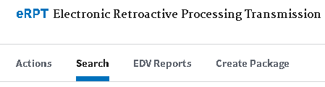

- Choose Review Packages in the “Search For (Required)” Drop-down menu:
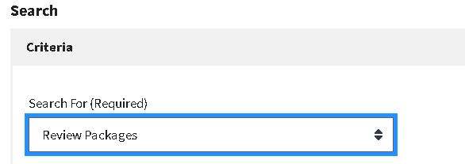

- Note the EDV Cycle month in the green banner at the top of the Plan EDV Report spreadsheet, and populate the “Date From (Required)” and “Date To (Required)” fields in eRPT with the first day and the last day of the month that encompasses the month shown in the Plan EDV Report.
- Using the Plan EDV Report for June of 2020 as an example, the Date fields should be populated as shown below:
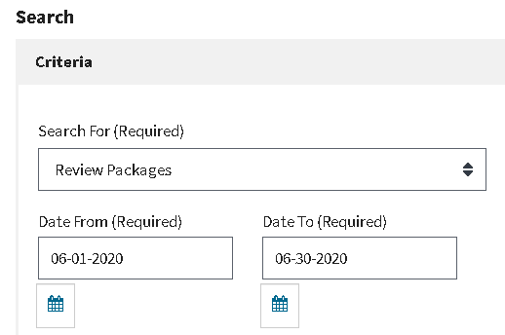

- Click the SEARCH button, and all EDV review packages posted to eRPT for your Organization for the month range searched should appear.

- If multiple EDV review packages were posted that month, you will need to search through each EDV review package to locate the transactions in question. The Transaction ID in the Plan EDV Report will be the same as the Transaction ID in the original EDV Sample Spreadsheet, and this ID begins with a hyphen a.k.a. minus sign (-).

Q. I see what was missing from the Response Documentation submitted that caused the non-compliant code to be assigned. How can I submit the corrected and/or additional documentation?
A. In the EDV review process, there is not an opportunity to submit additional documentation beyond what was added in the original Response Documentation for the transaction.

Q. If I see the error, but can’t submit the corrected documentation, what should I do now?
A. The best course of action in this scenario is to make note of the reason for the non-compliant code and to discuss the issue with your team. This will allow for a learning experience to ensure that the correct response documentation is submitted for similar transactions sampled in the future.

Q. I disagree with the non-compliant finding. Is there a way I can request a second review?
A. Yes. An EDV Dispute can be submitted to the RPC with the assistance of your Regional Office Account Manager. To initiate this process, please compile the information shown on the EDV Dispute Form on our website and forward this information to your Regional Office Account Manager.

Q. I’ve researched the transaction, but I still don’t understand why the non-compliant code was assigned. How can I determine what was wrong with the documentation submitted?
A. An EDV Dispute can also be initiated to obtain additional clarification regarding the non-compliant code assigned. If it is determined as part of the EDV Dispute that a non-compliant code was assigned in error, the code will be overturned, and the Plan’s compliance score will be updated.

Q. I’m trying to gather information for an EDV Dispute, but I can’t find the EDV Cycle number. Where is it located?
A. You are welcomed to provide the EDV Cycle month shown in the green banner at the top of the Plan EDV Report Spreadsheet instead of the EDV Cycle number.

Q. How will I know the outcome of the EDV Dispute?
A. When the EDV Dispute has been completed by the RPC, we will notify your Regional Office Account Manager of the outcome and your Regional Office Account Manager will share the results with you.

